Permanent Magnet DC Brushed and Brushless Motors

Justin Beemer, Michael Reber, Adithya Subbiah, Karthik Urs EECS 373 F19

Background Information 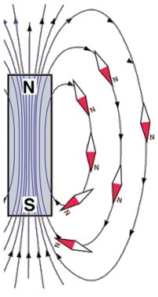

In a magnetic field (**B**), magnetic objects want to align their own field with the lines of the magnetic field.

See: Compass

Background Information

In the compass example, both the grey bar magnet and the compass needle have their own fields.

If you turn the bar magnet, **the needle will follow in order to align its field** with the bar’s field.

The needle turns because there is a **torque induced** by the misalignment of magnetic fields.

You can also create a magnetic field using a coil of conductive material...

Background Information

In the compass example, both the grey bar magnet and the compass needle have their own fields.

If you turn the bar magnet, **the needle will follow in order to align its field** with the bar’s field.

The needle turns because there is a **torque induced** by the misalignment of magnetic fields.

You can also create a magnetic field using a coil of conductive material...

Background Information

In the compass example, both the grey bar magnet and the compass needle have their own fields.

If you turn the bar magnet, **the needle will follow in order to align its field** with the bar’s field.

The needle turns because there is a **torque induced** by the misalignment of magnetic fields.

You can also create a magnetic field using a coil of conductive material...

Background Information

In the compass example, both the grey bar magnet and the compass needle have their own fields.

If you turn the bar magnet, **the needle will follow in order to align its field** with the bar’s field.

The needle turns because there is a **torque induced** by the misalignment of magnetic fields.

You can also create a magnetic field using a coil of conductive material...

Background Information

In the compass example, both the grey bar magnet and the compass needle have their own fields.

If you turn the bar magnet, **the needle will follow in order to align its field** with the bar’s field.

The needle turns because there is a **torque induced** by the misalignment of magnetic fields.

You can also create a magnetic field using a coil of conductive material...

Commutation

Recall the equation for torque on a current loop in a magnetic field: T = I**A** ⨉ **B**

where *T* is torque, *I* is current flowing through the loop, ***A*** is the area vector of the current loop, and ***B*** is the magnetic field vector.

In an electric motor, current flows through a loop/coil on an ***armature***. If you control ***B*** or ***A*** to maintain angular separation, there will be a constant torque and the armature will spin continuously.

Keeping these fields angularly separated is a process known as ***Commutation***.

Brushed DC Motors

Brushed DC (BDC) motors are the category of motors that achieve commutation using ***Brushes*** -- electrical conductors that mate with other conductors in a sliding interface. It’s easier to understand graphically:

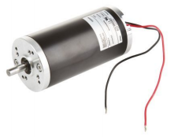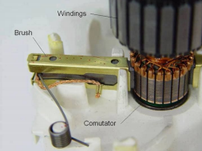

Brushed DC Motors 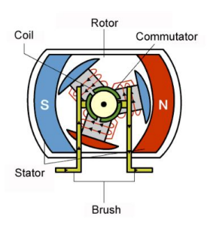

In the figure, the brushes are fixed (attached to the ***Stator***, along with a set of permanent magnets) and they electrically mate with the ***Commutator*** in order to change how current

flows in the coils that sit on the armature. The entire rotating assembly is called the ***Rotor***, which can be attached to a mechanical load to be moved.

Remember: with magnet(ic field)s, opposites attract!

Brushed DC Motors 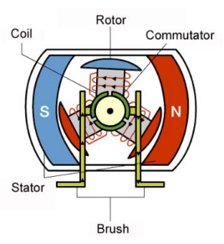

In the figure, the brushes are fixed (attached to the ***Stator***, along with a set of permanent magnets) and they electrically mate with the ***Commutator*** in order to change how current

flows in the coils that sit on the armature. The entire rotating assembly is called the ***Rotor***, which can be attached to a mechanical load to be moved.

Remember: with magnet(ic field)s, opposites attract!

Brushed DC Motors 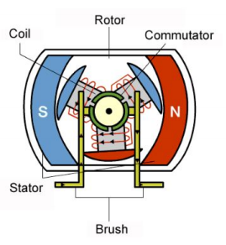

In the figure, the brushes are fixed (attached to the ***Stator***, along with a set of permanent magnets) and they electrically mate with the ***Commutator*** in order to change how current

flows in the coils that sit on the armature. The entire rotating assembly is called the ***Rotor***, which can be attached to a mechanical load to be moved.

Remember: with magnet(ic field)s, opposites attract!

Brushed DC Motors

In the figure, the brushes are fixed (attached to the ***Stator***, along with a set of permanent magnets) and they electrically mate with the ***Commutator*** in order to change how current 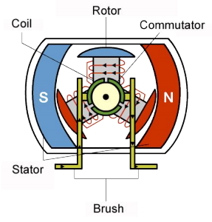

flows in the coils that sit on the armature. The entire rotating assembly is called the ***Rotor***, which can be attached to a mechanical load to be moved.

Remember: with magnet(ic field)s, opposites attract!

How to Use BDC Motors

To control a brushed DC motor, you need hardware for a **Power stage** between your processor and the terminals of the motor. 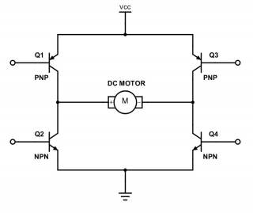

Two **half-bridges** can be combined to form an **H-bridge**, which when combined with your power supply and a PWM signal can control a brushed DC motor speed and direction.

How to Use BDC Motors

**If you turn on transistors Q1 and Q3, current will flow across the DC Motor in one direction, turning it via the process described earlier.** 

By turning on transistors Q2 and Q4, the current flows in the reverse direction and spins the motor in reverse.

By controlling the duty cycle of the PWM wave applied to the transistors, you change the apparent voltage across the motor and thus the motor speed.

How to Use BDC Motors

If you turn on transistors Q1 and Q3, current will flow across the DC Motor in one direction, turning it via the process described earlier. 

**By turning on transistors Q2 and Q4, the current flows in the reverse direction and spins the motor in reverse.**

By controlling the duty cycle of the PWM wave applied to the transistors, you change the apparent voltage across the motor and thus the motor speed.

How to Use BDC Motors

If you turn on transistors Q1 and Q3, current will flow across the DC Motor in one direction, turning it via the process described earlier. 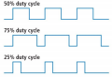

By turning on transistors Q2 and Q4, the current flows in the reverse direction and spins the motor in reverse.

**By controlling the duty cycle of the PWM wave applied to the transistors, you change the current through the motor and thus the motor speed.**

How to Use BDC Motors

If you turn on transistors Q1 and Q3, current will flow across the DC Motor in one direction, turning it via the process described earlier. 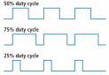

By turning on transistors Q2 and Q4, the current flows in the reverse direction and spins the motor in reverse.

**By controlling the duty cycle of the PWM wave applied to the transistors, you change the current through the motor and thus the motor speed.**

How to Use BDC Motors

If you turn on transistors Q1 and Q3, current will flow across the DC Motor in one direction, turning it via the process described earlier. 

By turning on transistors Q2 and Q4, the current flows in the reverse direction and spins the motor in reverse.

**By controlling the duty cycle of the PWM wave applied to the transistors, you change the current through the motor and thus the motor speed.**

Brushed DC Motors

Pros:

● Inexpensive ● Easy to control ● Simple to model

Cons:

● Large

● Heavy

● Wear from brushes

● Linear Torque Speed curve

Applications:

● Old electric

vehicles

● DIY

● Low cost, low power applications

Brushless DC Motors 

Brushless DC (BLDC) motors don’t have brushes to handle commutation -- it must be done

electronically!

The current through the coils is commutated electrically order to generate torque to spin on the rotor. 

The current on three inputs (known as ***Phases***) can be controlled using solid state power electronics (MOSFETs, IGBTs, BJTs).

How to Drive Brushless Motors

● Add another half bridge (three 

phases)

● Each half bridge controls a single

phase

● Transistors switch on and off (PWM)

to modulate current

● Capacitor and motor act and low 

pass filter.

○ PWM -> Sine wave

Brushless DC Motors: Control Strategies

Brushless motors require electrical commutation that can be achieved with a variety if control strategies.

***Trapezoidal Control Field-Oriented Control (FOC)***

Current 

Vector

Brushless DC Motors: Control Strategies

**Trapezoidal Control**

● Uses 3 digital sensor with 60 degree resolution

● Commutates the phases to maintain a ***B*** lead of 60-120 degrees (before jumping to the next state)

● This variable lead angle can cause ***Torque Ripple***.

● The algorithm is simple, but does not provide optimal performance

**Field-Oriented Control (Vector Control)**

● Uses a high-resolution rotary position sensor

● Samples phase currents to calculate and control current vector.

● Runs a feedback control loop to maintain a specified ***B*** lead current vector by 90 degrees

● Complex algorithm and hardware, but higher performance

Electronic Speed Controllers (ESCs)

DC Input

Three Phase Output

Hall effect sensor input

AC Inverters

Tractive Inverter from RMS

Brushless DC Motors

Pros:

● High power

density

● Non linear torque speed curve

● No wear from brushes

● Efficient

Cons:

● Expensive

● Hard to control

Applications:

● RC products ● Modern Electric Vehicles

● Industrial

machines and

drives

Basic Analysis for Motor Sizing (BDC)

**Avoid thinking of your problem in** 

**terms of speed.**

It takes **torque** to move things. **Power** is

how fast you can spin while applying that

torque.

**Power** = **Torque** ✕ Speed

Think of these two parameters first!

Basic Analysis for Motor Sizing (BDC)

1. Find the location of your application 

torque

2. Trace upwards and take note of the

intersections with the speed, power,

efficiency, and current curves

**S**

3. Evaluate if the values at those

**t**

**e**

**p**

intersections meet your criteria

**2**

**Step 1**

Basic Analysis for Motor Sizing (BDC)

Not fast enough? 

Not efficient enough?

Can’t sustain current draw?

● Get a bigger motor OR

● Gear your motor towards peak power

(if to the right -> gear down and vice

**Gear Down ~2:1**

**S**

**t**

**e**

**p**

versa)

**2**

● (or gear towards peak efficiency)

Ex: Gear down 2:1 -- Torque from motor

is halved; speed *more* than doubles;

efficiency increases (motor runs cooler)**Step 1**

Selection Guide

Numbers are a relative scale -- higher is better

**Property BDC BLDC - Trapezoidal BLDC - FOC** Simplicity/Affordability **3 2 1** Power/$ at low power **3 2 1** Power/$ at high power **1 2 3**

Power/Mass **1 2 3** Speed **1 2 2** Torque at low power **3 1 2** Torque at high power **1 2 3**

Questions?

Appendices

PMSM Induction Motors Switched Reluctance